***ML-Assignment # 2***

***Faraz Ahmed***

***Machine Learning Vs Data Science:***

***Machine Learning:***

Machine learning, a subset of artificial intelligence (AI), is a groundbreaking technology that enables computers to learn from data and improve their performance on specific tasks without being explicitly programmed. It has garnered significant attention and adoption across various industries due to its ability to make sense of vast amounts of data, make predictions, and automate decision-making processes.

At its core, machine learning relies on data. The more extensive and high quality the datasets, the more effective the machine learning model's training will be. These models often referred to as algorithms, extract patterns, and insights from data to make predictions or decisions. There are several key concepts and components of machine learning:

**Data**: Machine learning relies heavily on data. It requires large sets of structured or unstructured data to train models. This data can include text, images, numbers, and more.

**Algorithms:** Machine-learning algorithms are the core of the technology. These algorithms are used to analyze and process data, make predictions, classify objects, or optimize decisions. There are various types of machine learning algorithms, including supervised learning, unsupervised learning, and reinforcement learning.

**Deployment:** After training a machine-learning model, it can be deployed in real-world applications, such as self-driving cars, recommendation systems, fraud detection, and more.

***Data Science:***

* Data Science is a broader field that encompasses data collection, cleaning, exploration, and analysis to extract actionable insights and drive decision-making.
* It includes tasks like data preprocessing, exploratory data analysis (EDA), and data visualization, which are essential for understanding the data's context and quality.
* Data scientists use statistical analysis and domain knowledge to uncover patterns and trends in data.
* Data Science also includes building ML models, but it goes beyond just model development to encompass the entire data lifecycle.
* Ethical considerations, data privacy, and communication of results are essential aspects of data science.
* Data scientists often work closely with stakeholders to understand business objectives and ensure that data-driven insights align with organizational goals.

**Data Collection:** The first step in data science is gathering relevant data. This can include data from various sources, such as databases, sensors, websites, social media, or even manual data entry. Data scientists often work with both structured data (e.g., databases) and unstructured data (e.g., text, images, and videos).

**Data Cleaning and Preprocessing:** Raw data is often messy, incomplete, or inconsistent. Data scientists need to clean and preprocess the data to remove errors, handle missing values, and prepare it for analysis. This step is crucial for obtaining accurate and reliable results.

**Exploratory Data Analysis (EDA)**: EDA involves visualizing and summarizing data to understand its characteristics and identify potential patterns or outliers. Data scientists use techniques like data visualization, descriptive statistics, and dimensionality reduction to gain insights.

***Conclusion:***

ML is a specialized field within Data Science that focuses on creating predictive models, while Data Science encompasses a broader range of activities, including data collection, cleaning, exploration, and communication of insights. Both fields are essential for leveraging data to make informed decisions and drive innovation in various industries. They often work together, with Data Scientists utilizing ML techniques as part of their toolkit.

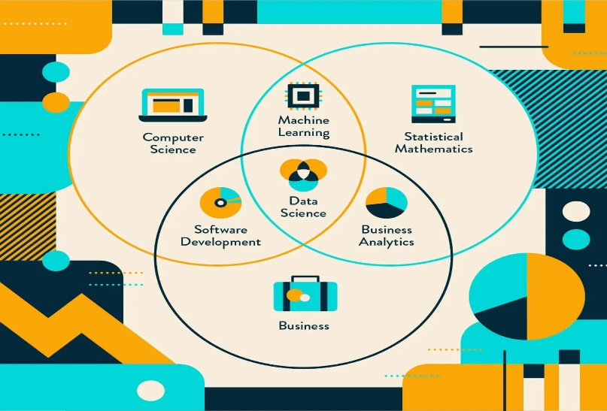

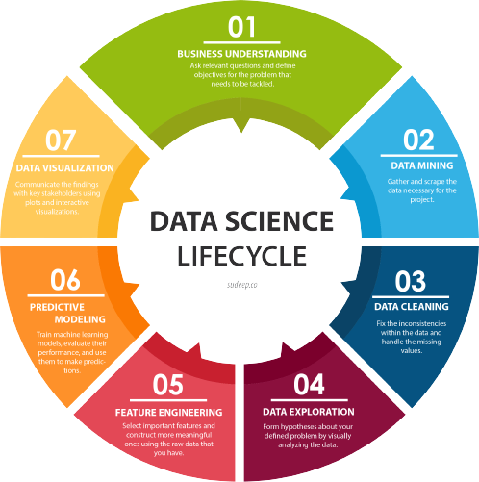

***Data Science Vs Artificial Intelligence (AI):***

***Objective:***

The objective of both Data Science and Artificial Intelligence (AI) is to harness data and technology for improved decision-making and problem solving. Data Science seeks to derive actionable insights from data, assisting in making informed choices and addressing immediate challenges, while AI aims to develop intelligent systems capable of autonomously handling tasks and decisions to enhance efficiency and provide immediate solutions in various applications. Together, they offer short-term benefits by enabling organizations to leverage data for better understanding, prediction, and automation, ultimately driving innovation and productivity across industries.

***Advantages of Data Science and Artificial Intelligence (AI):***

1. **Data-Driven Decision-Making**: Both Data Science and AI empower organizations to make informed decisions based on data analysis and predictive models, reducing guesswork and enhancing precision.
2. **Efficiency:** AI systems can automate tasks, streamline processes, and optimize resource allocation, leading to increased operational efficiency and cost savings.
3. **Scalability:** AI algorithms and data analysis techniques can handle vast amounts of data, making them suitable for large-scale applications.
4. **Effort Reduction:** Data Science tools and AI automate data cleaning, preprocessing, and model training, reducing manual labor and accelerating processes.
5. **Healthcare Advancements:** AI assists in medical image analysis, drug discovery, and patient care, leading to improved diagnostics and treatments.
6. **Natural Language Processing (NLP):** NLP, a subset of AI, enables chatbots, language translation, and sentiment analysis, enhancing communication and understanding.
7. **Data Security:** AI helps detect and mitigate security threats, while Data Science enhances data protection through advanced encryption and access control.
8. **Economic Growth:** Investments in Data Science and AI stimulate economic growth by creating jobs and driving innovation across industries.
9. **Environmental Impact**: Data Science and AI contribute to environmental conservation through applications like climate modeling and resource management.
10. **Customer Insights**: Data Science analyzes customer data to gain insights into behavior and preferences, allowing businesses to tailor marketing strategies.

***Disadvantages of Data Science and Artificial Intelligence (AI):***

1. **Data Privacy Concerns**: Collecting and analyzing vast amounts of data can raise privacy issues, as individuals may be concerned about how their data is used, stored, and shared, leading to potential regulatory challenges like GDPR.
2. **Bias and Fairness**: Data used to train AI models may contain biases, leading to biased predictions or decisions. Ensuring fairness and mitigating bias is a complex and ongoing challenge.
3. **Complexity and Resource Intensity**: Implementing AI and Data Science solutions can be resource-intensive in terms of computational power, data storage, and skilled personnel, making them costly for some organizations.
4. **Lack of Transparency**: Deep learning models can be difficult to interpret, making it challenging to understand why they make specific decisions, which can be a concern in critical applications like healthcare and finance.
5. **Security Vulnerabilities**: AI systems can be susceptible to attacks and adversarial inputs, posing security risks in various domains, including autonomous vehicles and cybersecurity.
6. **Data Quality and Bias:** Poor data quality can lead to inaccurate insights and decisions. Additionally, biased data can perpetuate inequalities and discrimination.
7. **Overfitting:** In Data Science, overfitting can occur when models are too complex and perform well on training data but poorly on new, unseen data.
8. **Dependence on Data:** Data Science and AI heavily rely on data availability. Insufficient or biased data can limit the effectiveness of models.
9. **Complexity for Small Businesses:** Small businesses may struggle to implement and benefit from AI and Data Science due to the complexity and cost involved.
10. **Environmental Impact**: The energy consumption of large-scale AI models and data centers can have a significant environmental impact.

***Problem Statements and Examples of Data Science & AI:***

**Business Problem Statement:**

* **Problem:** Customer churn rate in our subscription-based service is high, resulting in revenue loss and decreased customer satisfaction.
* **Impact:** Declining profits, reduced customer lifetime value, and negative brand reputation.
* **Objective:** Develop a customer retention strategy to reduce churn by 20% within the next quarter.

**Healthcare Problem Statement:**

* **Problem:** Hospital readmission rates for patients with chronic diseases are consistently above the national average.
* **Impact:** Increased healthcare costs and patient discomfort due to frequent hospitalizations.
* **Objective:** Implement a predictive model to identify high-risk patients and develop personalized care plans to reduce readmission rates by 15% in the next year.

***Examples:***

**Healthcare - Disease Prediction:**

* **Data Science:** Data scientists can analyze patient health records, lab results, and medical history to identify patterns associated with specific diseases.
* **AI:** AI algorithms can be used to build predictive models that assess an individual's risk of developing a particular disease, such as diabetes or cancer, based on their health data.

**Education - Personalized Learning:**

* **Data Science:** Data scientists can analyze student performance data to identify areas where individual students may need additional support.
* **AI:** AI-driven personalized learning platforms can adapt coursework to each student's abilities and learning pace, improving educational outcomes.

***Conclusion:***

Data Science and Artificial Intelligence (AI) are transformative technologies that offer numerous advantages across various domains, from improving decision-making and efficiency to driving innovation and economic growth. However, they are not without their disadvantages and challenges, including concerns about data privacy, bias, transparency, and job displacement. Data Science and AI in improving healthcare, optimizing business processes, enhancing user experiences, and addressing complex societal challenges are vast. By addressing the disadvantages and harnessing the advantages, we can navigate the evolving landscape of data-driven technologies to create a future where Data Science and AI benefit individuals, organizations, and society as a whole.

***Machine Learning Types and Differences with Examples:***

***Types of Machine Learning:***

* ***Supervised Learning:*** In this approach, algorithms are trained on labeled data, where input data is paired with corresponding correct output. The model learns to map inputs to outputs, making it suitable for tasks like classification and regression.
* ***Unsupervised Learning:*** This type of learning deals with unlabeled data, where the algorithm aims to discover patterns, clusters, or structure within the data. Common techniques include clustering and dimensionality reduction.
* ***Reinforcement Learning:*** Inspired by behavioral psychology, reinforcement learning involves agents that learn through interaction with an environment. They take actions and receive feedback in the form of rewards or penalties, enabling them to make optimal decisions over time.

***Deep learning:*** Deep learning a subset of machine learning, has gained prominence due to its success in complex tasks. Deep neural networks, modeled after the human brain's structure, are used for tasks such as image recognition, natural language processing, and autonomous driving.

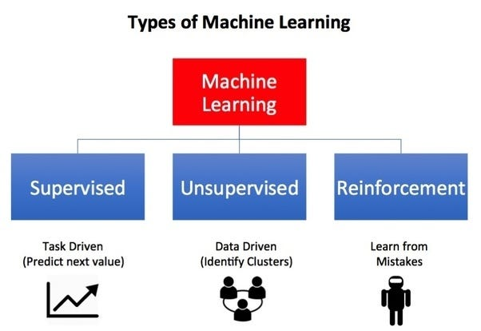

1. **Supervised Learning:**

* **Objective:** Learn a mapping from input data to output labels based on a labeled training dataset.
* **Characteristics:** The algorithm is provided with a dataset where each example has a known label or target. It learns to make predictions by mapping input features to these known labels.
* **Labeled Data**: It requires a labeled dataset, where each data point has a corresponding target or label.
* **Examples:** Classification (e.g., spam email detection, image classification), Regression (e.g., house price prediction), and Named Entity Recognition.

1. **Semi-Supervised Learning:**

* **Objective:** Combine both labeled and unlabeled data to improve model performance, especially when obtaining labeled data is expensive or time-consuming.
* **Examples:** Speech recognition, image classification.

1. **Unsupervised Learning:**

* **Objective:** Find patterns or structures in unlabeled data, typically for clustering, dimensionality reduction, or density estimation.
* **Lack of Labels**: It operates on data without known target labels or explicit feedback.
* **Characteristics:** The algorithm works with unlabeled data and aims to discover hidden patterns, group similar data points, or reduce the data's complexity without explicit target labels.
* **Examples:** Clustering (e.g., customer segmentation, document clustering), Dimensionality Reduction (e.g., Principal Component Analysis, t-SNE), and Anomaly Detection.

1. **Reinforcement Learning:**

* **Objective:** Learn a policy that maximizes a reward signal by interacting with an environment, often used in sequential decision-making tasks.
* **Agent-Environment Interaction**: It involves an agent interacting with an environment, taking actions, receiving feedback (rewards or penalties), and adapting its behavior over time.
* **Characteristics:** Agents take actions in an environment, receive feedback in the form of rewards or punishments, and learn to optimize their actions over time through trial and error.
* **Examples:** Game playing (e.g., Alpha Go, reinforcement learning in video games), Robotics (e.g., robot navigation, control), and Autonomous Driving.

***Conclusion:***

The choice of which type of machine learning to use depends on the problem at hand, the availability of labeled data, and the specific learning objectives. In practice, hybrid approaches and advanced techniques often bridge the gaps between these types to tackle complex real-world challenges. Understanding the differences and capabilities of each type is crucial for designing effective machine learning solutions that meet the needs of diverse applications across various domains.

***Python:***

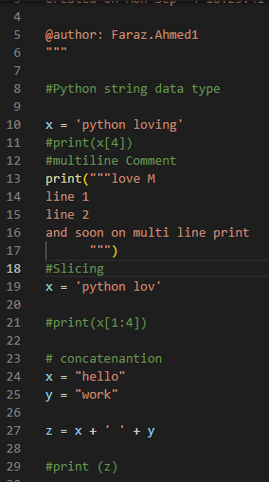



Python is a widely used programming language known for its versatility and simplicity. Python, created by Guido van Rossum and first released in 1991, has emerged as a dominant force in the world of programming. Known for its simplicity, readability, and versatility, Python has become a go-to choice for a wide range of applications, from web development to artificial intelligence. Python's design philosophy emphasizes code readability, with a clean and straightforward syntax that favors human-readable code over complex syntax. Its name is derived from the British comedy group Monty Python, reflecting Guido's fondness for their work.

Python's simplicity and ease of learning make it an excellent choice for both beginners and experienced developers. Its syntax is clear and easy to understand, using indentation for block structure, which enhances code readability. One of Python's standout features is its versatility. It supports multiple programming paradigms, including procedural, object-oriented, and functional programming. This flexibility allows developers to choose the best approach for their projects, making it a language suitable for various applications.

Python comes with a rich standard library, providing pre-built modules and functions for a wide range of tasks, from file handling to web development. This extensive library saves developers time and effort, enabling them to focus on solving specific problems rather than reinventing the wheel. Cross-platform compatibility is another strength of Python. It is available on various operating systems, including Windows, macOS, and Linux, ensuring that code written in Python can be run on multiple platforms without modification.

Python's large and active community of developers contributes to an extensive ecosystem of libraries and frameworks. Popular libraries like NumPy, pandas, and TensorFlow are widely used in data science and machine learning, making Python the language of choice for these fields. The language's ease of integration with other languages and tools is another significant advantage. Python can be seamlessly integrated with languages like C/C++, Java, and .NET, making it a popular choice for scripting and automation tasks.

Python finds applications in various domains:

* **Web Development:** Python frameworks like Django and Flask simplify web application development, allowing developers to build robust and scalable web solutions.
* **Data Science and Machine Learning:** Python is the de facto language for data analysis and machine learning. Libraries like NumPy, pandas, and scikit-learn enable researchers and data scientists to analyze and model data efficiently.
* **Artificial Intelligence:** Python's simplicity and AI-focused libraries like TensorFlow and PyTorch make it a preferred language for developing AI applications, including natural language processing and computer vision.
* **Scientific Computing:** Python's extensive ecosystem is widely used in scientific computing, enabling researchers to perform complex simulations, data analysis, and visualization.
* **Automation:** Python's scripting capabilities are invaluable for automating repetitive tasks, system administration, and data processing.
* **Game Development:** Python is used in game development, with libraries like Pygame providing tools for creating 2D games and prototypes.

Python's popularity continues to grow, and it remains a top choice for developers and organizations worldwide. Its extensive use in emerging fields like data science, machine learning, and artificial intelligence positions it for a promising future. Python's community-driven development ensures that it will continue to evolve, adapt, and remain relevant in the rapidly changing technology landscape.

***Advantages of Python:***

Python stands out as a programming language of remarkable versatility and accessibility. It is clear and readable syntax, extensive standard library, and a thriving community of developers have propelled it to the forefront of technology across diverse domains. From web development to data science, artificial intelligence, and automation, Python offers solutions for a wide array of applications. Its adaptability, cross-platform compatibility, and seamless integration with other languages make it a valuable choice for both beginners and experienced developers. Python's ongoing evolution and open-source nature ensure its enduring relevance in the ever-changing landscape of technology, solidifying its position as a pivotal tool for innovation, problem solving, and education.

* **Readability and Simplicity**: Python's clear and straightforward syntax emphasizes code readability, making it easy for developers to write and maintain code. This simplicity is especially beneficial for beginners and contributes to reduced development time.
* **Large and Active Community**: Python has a large and active community of developers and users. This community support is valuable for finding solutions to problems, sharing knowledge, and accessing a wealth of resources, including libraries, frameworks, and tutorials.
* **Integration Capabilities**: Python can easily integrate with other programming languages, such as C/C++, Java, and .NET. This interoperability makes it a suitable choice for scripting, extending existing software, and integrating diverse systems.
* **Data Science and Machine Learning**: Python has become the language of choice for data science and machine learning due to its extensive libraries and frameworks, including NumPy, pandas, scikit-learn, and TensorFlow. These tools facilitate data analysis, modeling, and research in various domains.
* **Web Development:** Python offers powerful web development frameworks like Django and Flask, which simplify the creation of robust and scalable web applications. These frameworks follow the Don't Repeat Yourself (DRY) principle, promoting code efficiency and maintainability.
* **Artificial Intelligence (AI) and Natural Language Processing (NLP):** Python's simplicity and libraries like TensorFlow, PyTorch, and NLTK make it a preferred language for developing AI and NLP applications. This includes speech recognition, image processing, and chatbots.
* **Educational Resource**: Python is often recommended as a first programming language for beginners due to its simplicity and readability. It serves as an excellent educational resource for learning programming concepts.

***Disadvantages of Python:***

Python, while celebrated for its versatility and readability, does come with certain disadvantages. Its interpreted nature can lead to performance bottlenecks, making it less suitable for computationally intensive tasks. The Global Interpreter Lock (GIL) restricts true parallelism in multi-threaded applications, limiting its use in high-performance scenarios. Additionally, Python's memory consumption can be higher due to dynamic typing and object-oriented features, impacting its suitability for resource-constrained environments. Furthermore, its presence in mobile app development and game development lags behind languages like Java, Swift, and C#. While Python is a powerful and popular language, developers should weigh these limitations against its benefits when choosing it for specific projects.

* **Performance**: Python is an interpreted language, which can result in slower execution compared to compiled languages like C++ or Java. This can be a drawback for applications that require high computational performance, such as real-time systems and resource-intensive simulations.
* **Global Interpreter Lock (GIL)**: Python's Global Interpreter Lock (GIL) restricts the execution of multiple threads within a single process. This limitation can hinder the full utilization of multi-core processors, making Python less suitable for CPU-bound tasks that require parallelism.
* **Memory Consumption**: Python's dynamic typing and object-oriented nature can lead to higher memory consumption compared to languages with more efficient memory management. This can be a concern for applications dealing with large datasets or running on resource-constrained devices.
* **Limited Mobile and Game Development**: Python is less commonly used for developing mobile apps and video games compared to languages like Java (for Android) and C# (for Unity game development). This limits its presence in these specific markets.
* **Learning Curve for Some**: Although Python is considered beginner-friendly; newcomers may still face a learning curve when dealing with more advanced concepts, such as decorators, metaclasses, and memory management.

***Conclusion:***

Python's simplicity, versatility, and extensive ecosystem have established it as a dominant force in the world of programming. Whether you are a beginner learning to code or an experienced developer tackling complex projects, Python offers the tools and resources necessary to bring your ideas to life. Its impact on various industries and its bright future make Python a language worth mastering for anyone in the world of technology and software development. Python is a remarkable programming language with a myriad of advantages, including readability, versatility, a vast ecosystem of libraries, and a thriving community. However, it does have its share of disadvantages, such as potential performance limitations, memory consumption, and restrictions in certain domains like mobile app and game development. The key to successfully leveraging Python lies in understanding its strengths and weaknesses and choosing it judiciously based on project requirements. Its enduring popularity and continual evolution in response to community needs affirm Python's enduring relevance as a powerful tool for a wide array of applications in the ever-evolving landscape of technology.

***Mathematics vs Statistics:***

***Mathematics:***

1. **Fundamental Language:** Mathematics is the foundation of quantitative reasoning and provides a universal language for expressing and solving problems in various disciplines, including physics, engineering, computer science, and more.
2. **Abstract and Theoretical:** Mathematics is often highly abstract and theoretical, focusing on the development of formal structures, proofs, and theorems. It deals with concepts like numbers, sets, functions, and geometrical properties.
3. **Problem Solving:** Mathematics is concerned with solving complex mathematical problems and proving mathematical statements. It is applicable in a wide range of fields to model, analyze, and solve problems using mathematical tools and techniques.
4. **Pure vs. Applied:** Mathematics is divided into two broad categories: pure mathematics, which explores mathematical concepts for their own sake, and applied mathematics, which applies mathematical methods to solve real-world problems.

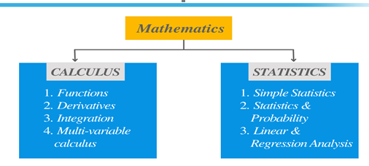

***Statistics:***

1. **Data Analysis:** Statistics is primarily concerned with the collection, organization, analysis, interpretation, and presentation of data. It provides methods for summarizing and drawing inferences from data.
2. **Empirical and Practical:** Statistics is empirical and practical, dealing with real-world data and observations. It focuses on making informed decisions and predictions based on data, often involving uncertainty.
3. **Descriptive vs. Inferential:** Descriptive statistics involve summarizing and presenting data, while inferential statistics deal with drawing conclusions and making predictions about populations based on sample data.
4. **Applications:** Statistics is widely used in fields such as economics, social sciences, biology, business, and healthcare to analyze trends, make forecasts, conduct experiments, and test hypotheses.

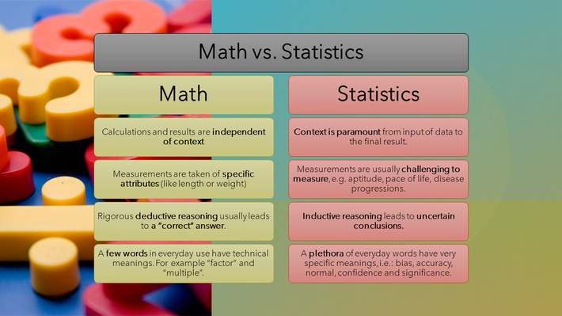

***Measures of Central Tendency:***

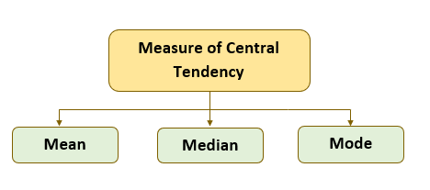

Measures of central tendency are statistical measures used to describe the center or average value of a data set. They provide a way to summarize and understand the central or typical value within a set of observations. The three primary measures of central tendency are:

1. **Mean (Average):**

* **Formula:** Mean = (Sum of all values) / (Number of values)
* **Description:** The mean is the most common measure of central tendency and is calculated by adding up all values in the data set and dividing by the total number of values. It represents the balance point of the data.

1. **Median:**

* **Description:** The median is the middle value in a sorted list of data. If there is an even number of values, it is the average of the two middle values. The median is less sensitive to extreme outliers compared to the mean.
* If the dataset has an odd number of values (n):
  + Median = Middle value when the data is sorted.
* If the dataset has an even number of values (n):
  + Median = (Value at position n/2 + Value at position (n/2 + 1)) / 2

1. **Mode:**

* **Description:** The mode is the value that appears most frequently in a data set. A data set can have no mode, one mode (unimodal), or multiple modes (multimodal). The mode is especially useful for categorical or discrete data.

We can find mode just by arranging the data in ascending and descending order and then finding the value, which occurs most frequently. In grouped data, we can find the mode by using the following formula,

* **Mode** = L + (f 1– f 0/2f 1– f 0– f 2) h.

